Figure 2: LCMS chromatograms of brain (A), liver (B), kidney (C), stomach (D), blood (E), vitreous humor (F), green chewed plant (G), blank (H), positive control (I) and negative control (J). (1) is the window of internal standard (amphetamine – D5), (2) is the window of amphetamine, (3) is the window of cathine and (4) is the window of cathinone.

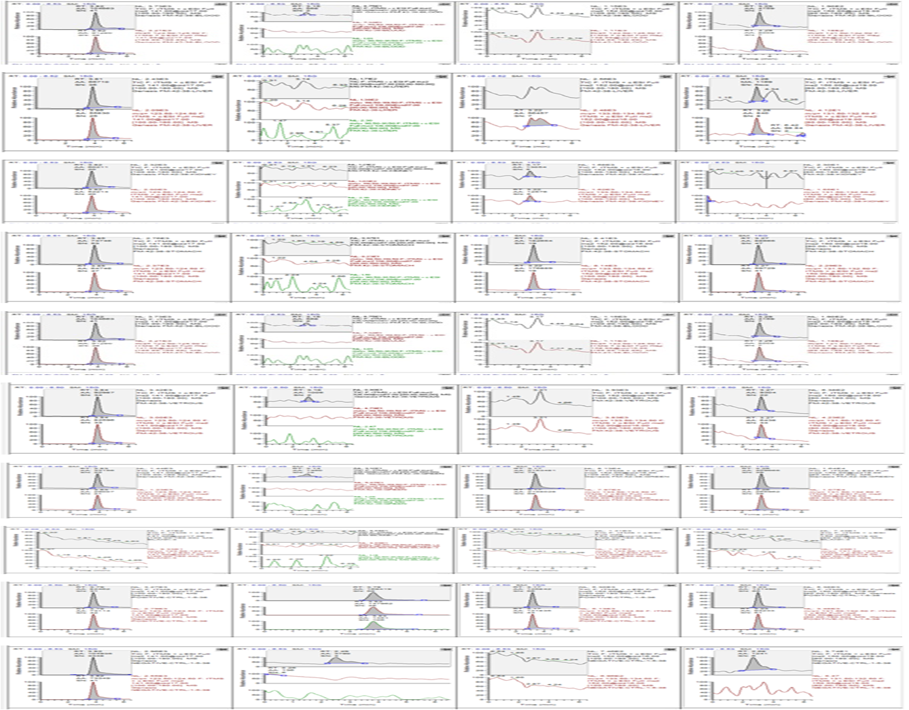

A

E

C

B

D

F

I

H

G

J

1

3

4

2